**Project Selection Page**

* LR logo appears blurry -> to use a higher quality image  
  => Can you please provide us the high resolution logo?
* Blue header bar to be thicker to give some spacing top and bottom for words and better ratio of colours and sections, except for mobile with limited screen estate (refer to InVision designs)
* Design issue
* On 1920x1200 screen, filter column on left and project cards are too wide (too much white space). Filter column width to be reduced and fixed to a maximum, project cards to allow up to 4 in a row instead of 3
* Issue due to grid system.
* Recent Active Projects and Total Projects font increase to same size or bigger than project name
* DEV
* “FILTER BY COUNTRY” to be changed to “Filter by country”  
  => DEV
* “Manage Account” to be changed to “Manage Accounts”  
  => DEV
* “Sitename” to be changed to “Site Name”  
  => DEV
* Slow transition into Manage Accounts and individual project pages. To add a spinning wheel on browser tab when moving between pages.  
  => DEV
* Mouse over search bar: Words and line turns white bold even before clicking  
  => ??
* Mouse over project cards: project name turns blue and blue highlight around card  
  => Do you mean we need t turn project name color to be blue and highlight around card?
* Mouse over country filter list: words and number turn blue, row shaded with light grey background   
  => ok
* Mouse over language options list: symbol/words turn blue, row shaded with light grey background  
  => Dev
* Mouse over Manage Accounts link: symbol/words turn blue  
  => Dev
* Mouse over Logout link: symbol/words turn blue, tooltip “Logout”  
  => Dev
* Mouse over plus symbol: flash animation, tooltip “Create New Project”, flash again when clicked  
  => We can change the shadow effect on mouse hover.
* Mouse over burger menu symbol: tooltip “More Options”, words turn blue and row shaded with light grey  
  => Dev
* Project cards to be sorted by last visit for each user, even when filtered  
  => Currently database has no provision for tracking project for each users so lets push it to next sprint.

**Manage Accounts Page**

* Mouse over path directory: white bold with underline  
  => Dev
* Mouse over search icon for project list: turn blue  
  => Dev
* Click on search icon for project list: search field enabled and ready to type  
  => Dev
* Mouse over project cards: project name turns blue and blue highlight around card  
  => ??
* Mouse over search bar: Icon, words and line turns blue even before clicking  
  => Dev
* For mobile, “Administrator” to be changed to “Admin” to resolve word spacing issue  
  => Dev
* When Org Admin demotes a Project Admin while the Project Admin is in the Manage Accounts page, the Project Admin still retains his admin rights and is able to save changes to role assignments successfully. This is a security issue. When the save button is clicked, the system should first query the rights of the user. If user has rights, save changes with message “Successfully updated”. Otherwise, user should see an error message “Unauthorized changes” then the page is refreshed.  
  => Dev

**Create New Project Page**

* “DBA Create New Project” to be changed to “Create New Project”  
  => Dev
* Light grey background permanently on for 1st item in drop down list -> needs to be fixed  
  => It’s default behavior and cannot be overwrittern instead can we do:

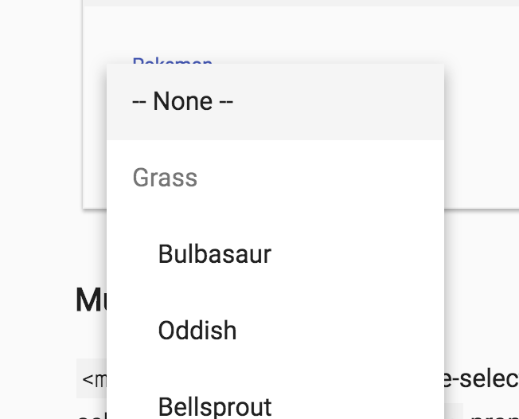

* Shortcut to selecting option in drop down list by typing, first letter type is not responsive e.g. first press of F nothing happens, only on second press the list will jump to options starting with F. In addition, shortcut typing is too fast or not responsive. E.g. typing F, I, N for Finland is sometimes successful and sometimes not.  
  => Dev

**Home Page**

* “PROJECT CODE” to be changed to “Project No.”
* “Project No.: …” font colour to be changed to black
* “Sitename” to be changed to “Site Name”
* “Create/Update Record” to be changed to “Create/Update Records”
* “Recommendation” to be changed to “Recommendations”
* Font size increase for “To start with your Barrier Analysis…”
* “To start with your Barrier Analysis…” font colour to be changed to black
* Mouse over left menu column: row shaded with light grey
* “DBA Settings – Work Type” to be changed to “Settings – Work Type”
* “DBA Setting – Work Operation” to be changed to “Settings – Work Operation”
* “DBA Setting – Potential Incident” to be changed to “Settings – Potential Incident”
* “DBA Setting – Consequence Type” to be changed to “Settings – Consequence Type”
* “S.N” to be changed to “S/No”
* To add a path to return to Project List page in the menu, or to add a back button in place of the breadcrumbs

**Settings Page**

* “Pre-defined Lists” font size increase with no underline
* Work type, work operation, potential incident and consequence type to be flushed to the left
* Mouse over edit icon: tooltip “Edit”
* Mouse over delete icon: tooltip “Delete”

**Workshop Page**

* Table is cut-off on mobile, can only see 2 columns and unable to horizontal scroll

**Create/Update Records Page**

* Scandinavian languages not implemented for Barrier Type and Dependency
* What triggers the message for “Couldn’t create the record”?
* When there are no recommendations, input fields from New Risk Ranking are disabled since New Risk Ranking should be equal to Current Risk Ranking when there are no recommendations. To build in additional validation rule.
* All free text fields should not be compulsory for submission e.g. “Incident Description”.
* Submit button should be always enabled. When clicked without all required fields, the form will highlight all empty mandatory fields red as prompt to the user. This should be standard UX.
* Submit button text to change based on situation. Text is “Submit New” for new records, “UPDATE” for update records. Provides clarity to user on new or update action.
* When selecting records, only categories with records should be shown for work type, work operation and potential incident, so that user will not see categories without records and get confused with a long list.
* When RESET button is clicked, form returns to the top.
* What happens after user submits new record or update record. Should the fields be cleared, or retained?

**Safe Job Analysis Page**

**Recommendations Page**

**General**

* All buttons to be in orange colour, except CANCEL will be in grey
* All buttons to have flash animation when mouse over and flash animation when clicked
* For mobile, menu needs to be collapsible (refer to [Google material design](https://material.io/guidelines/patterns/navigation.html))
* For mobile, not responsive when phone orientation changes to landscape
* Risk matrix does not scale with size changes -> responsive design issue (tested on smaller laptop screen size, tablet and mobile)

**IE Browser**

* Text are all over the place
* Many issues and generally not fit for testing